Aslan Oztreves

CS 435

Matthew Burlick

Homework #1

Theory Problems

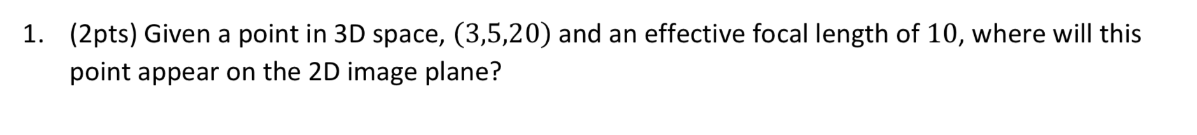

**Part1**

**Part2**

1. 𝑡=25%

1. 𝑡=50%

1. 𝑡=75%

**Part3**

**Part4**

Original Image

Stretched Image

Histograms

I have stretched it from 30-130 to 0-255 because the graph calculation was concentrated between that area which made it more spread out. This way we balanced the linear graph and make the contrast more even. In this case brighter.